

City Bus Management System

DBMS Course Project

final report

Pushpita Patil | 15CO235 | Nihala Karapoola | 15CO231

July-December 2017

# INTRODUCTION

## Project Aim

To design an effective and efficient database management system to book bus seats, for commute in the Manipal-Udupi-Mangalore area. The site designed will also allow for login functionality, and of different types of users (admin and customer).

## Relevance

In the Manipal-Udupi-Mangalore area, we have observed that there does not exist a system to track inter-city buses. First time visitors have no idea where the bus standing in front of them will go. Also, within the city of Mangalore, there exist many bus routes, that are confusing, and have a haphazard schedule.

## Current system

The customers have to ask the conductor where the bus will be going, and if they can be dropped at their stop. There is no centralized system to enable smooth, transparent and formalized functioning of the city bus route system.

Bus owners have no information about the customers they are servicing, and with this system, they will obtain more data to optimize their service.

## Proposed system

Our system proposes that customers use our application to ensure a safe travel from anywhere to anywhere in the area.

All they have to do is log in, and enter the details of their travel. The system will confirm a seat for them, and provide details of the bus they will go on.

This is different from the long distance travel booking, for the reasons that our system is much faster and simpler, as this is a small scale application. The customer will not need to pick a bus, and will instead receive the first bus that suits their requirements, as it is in real life.

## Project Description

Front End tools used: HTML, CSS, JavaScript, Materialize.

Back End tools used: PHP, MySQL, XAMPP.

## Objectives and success criteria of the project

The customers and bus owners must have separate login portals, as they have different functions.

The customers should be able to book seats on a bus, to wherever they wish to go, as long as the bus owners have mentioned that their bus goes by the route required.

The bus owners must be able to view all details of the whole system, from their login.

The system must handle booking failure cases where a bus is not available, for any of the following reasons:

* There is no bus going by the route at the time.
* All seats of the required bus are full.
* The route mentioned does not have the required dropping and picking points.

# REQUIREMENT ANALYSIS

## Overview

The remaining section of the document provide a general description of the system, which includes user characteristics, functional and non-functional requirements of the product.

## User characteristics

### Customer

The person who books seats on a bus for his commute from one stop to another stop.

### Bus owner

The person who has the ability to mention which buses are running (or active) and can be booked. They also can register new buses with routes.

### System admin

This is the technician who handles the backend database. He handles the city map, and the overall functioning of the system.

For example, if any route need to be added or modified, he needs to login to the phpMyAdmin and update the route tables there.

## Functional requirements ("shall lists")

### Display Basic Info

### 

This is the Home Page.

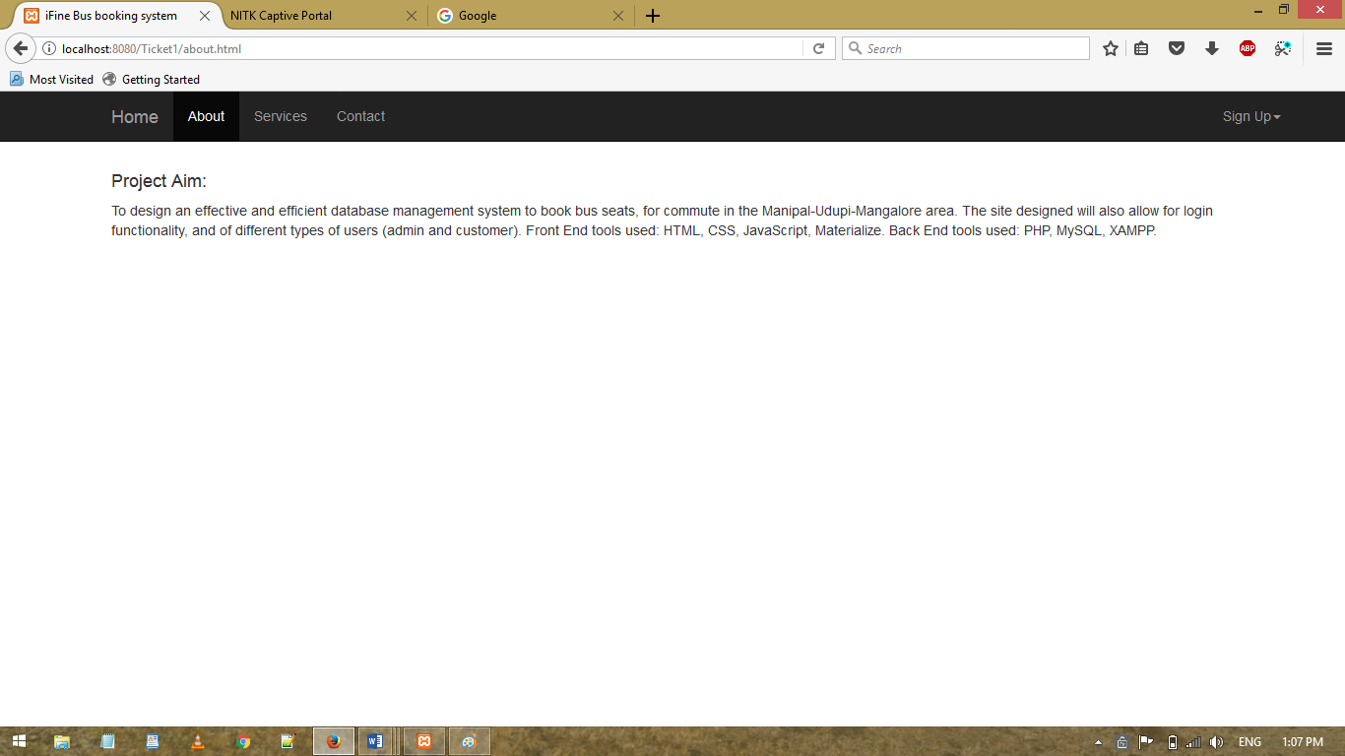

This is the About Page, where the project description is given.

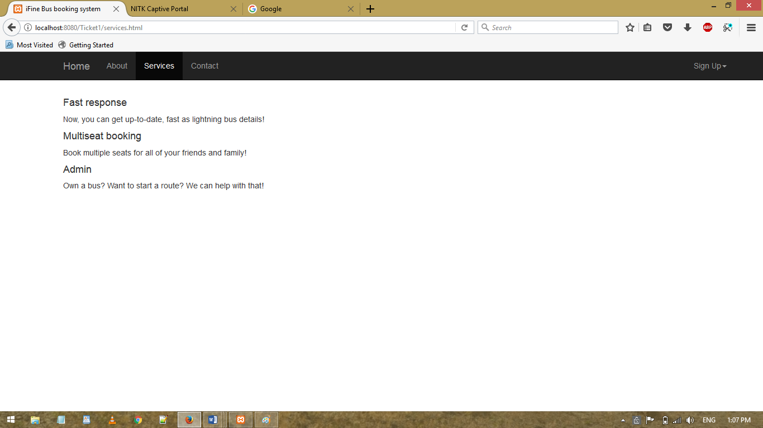

This is the Services page where an advertisement message about the system can be conveyed.

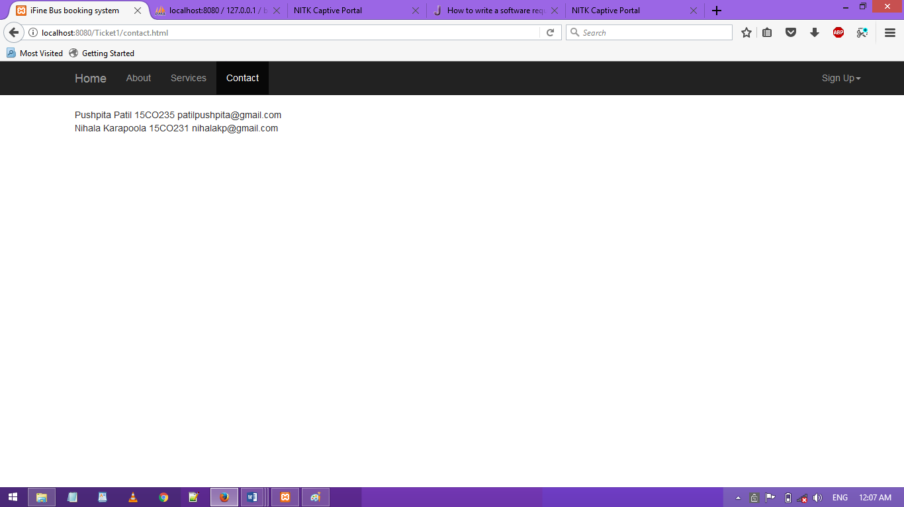

### Register New Owner

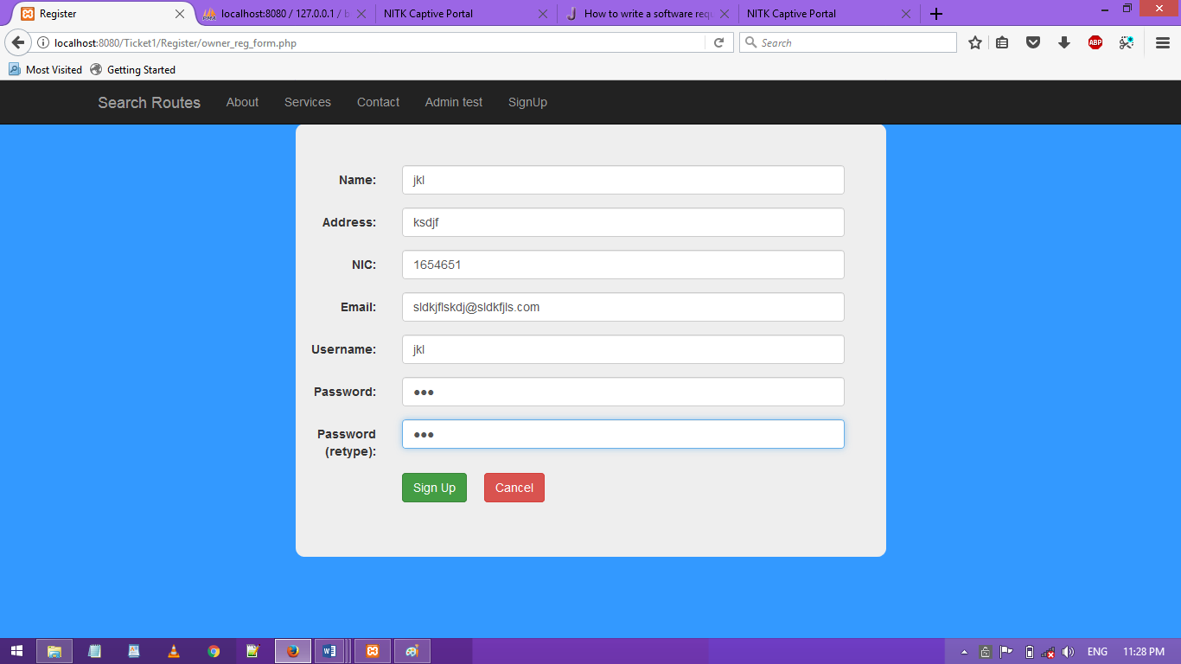

### Login as Owner

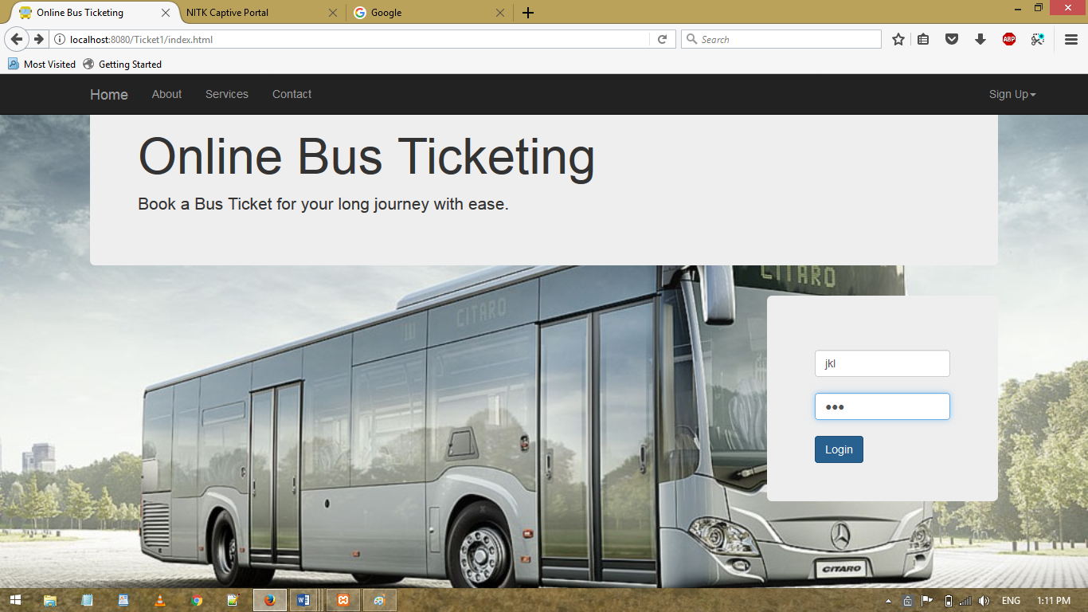

### Register a New Bus

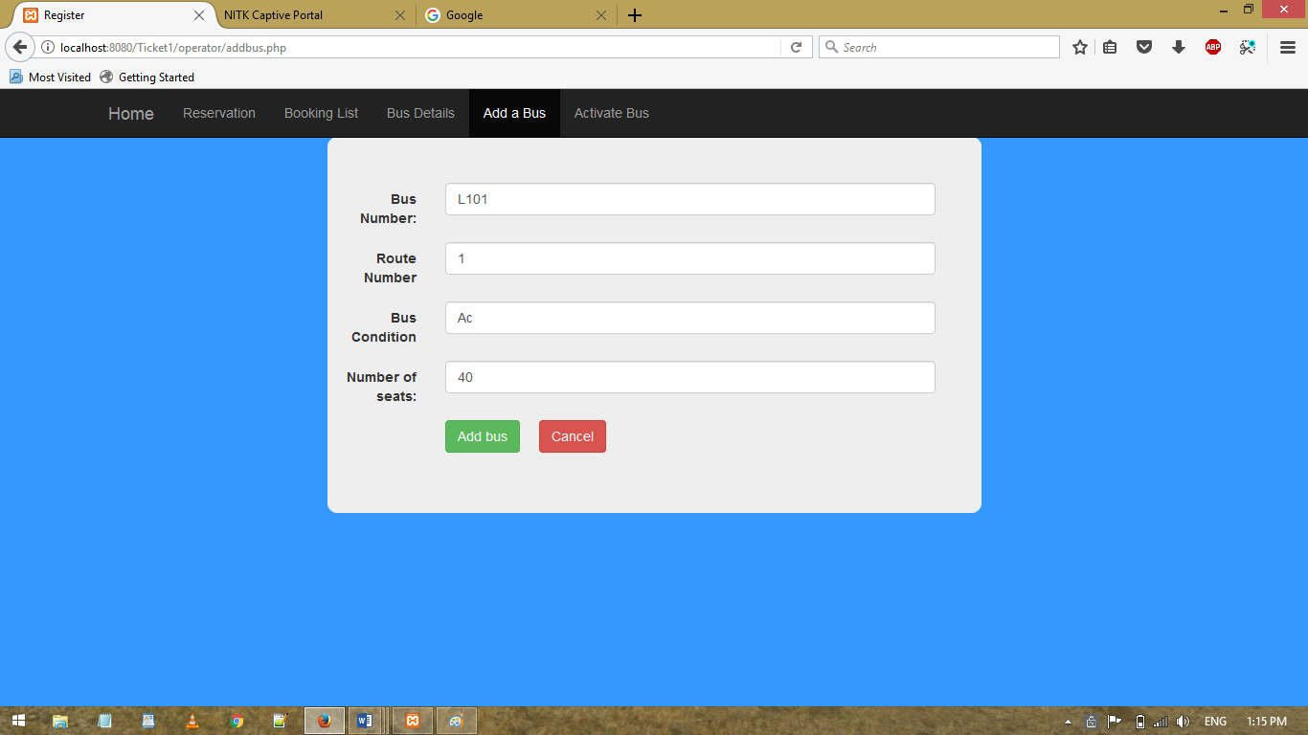

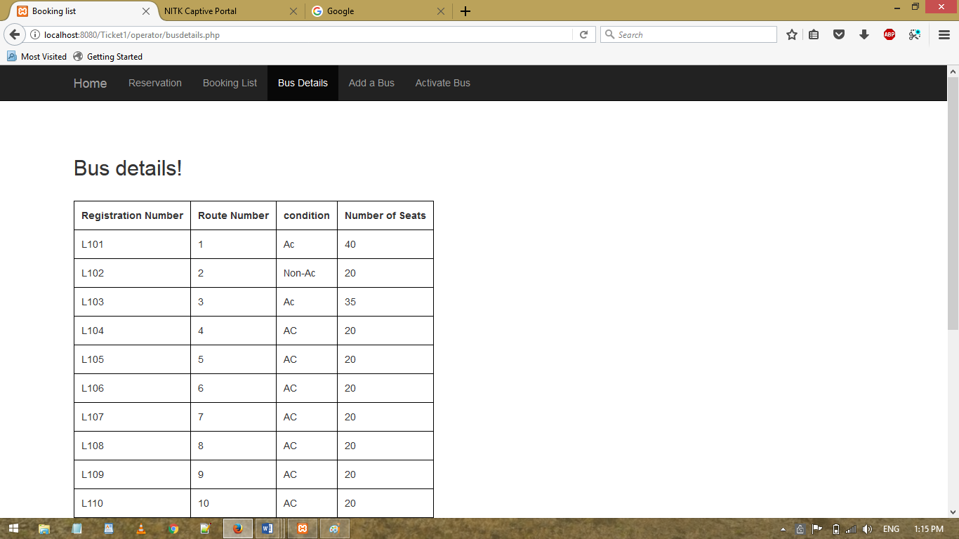

### Activate an Existing Bus

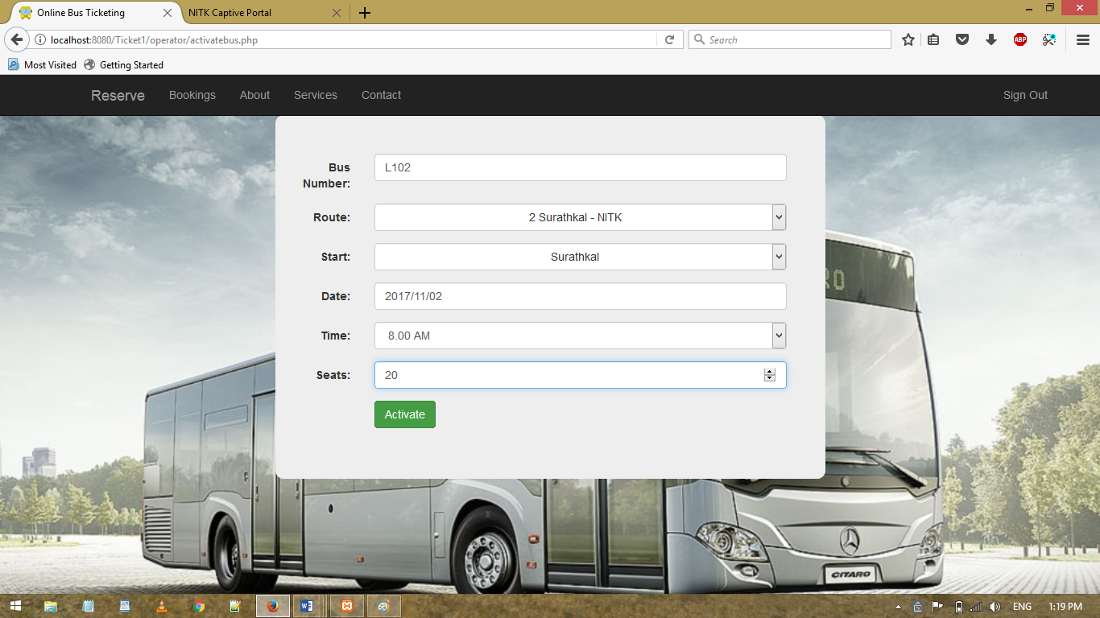

### Reserve a Bus seat as an Owner

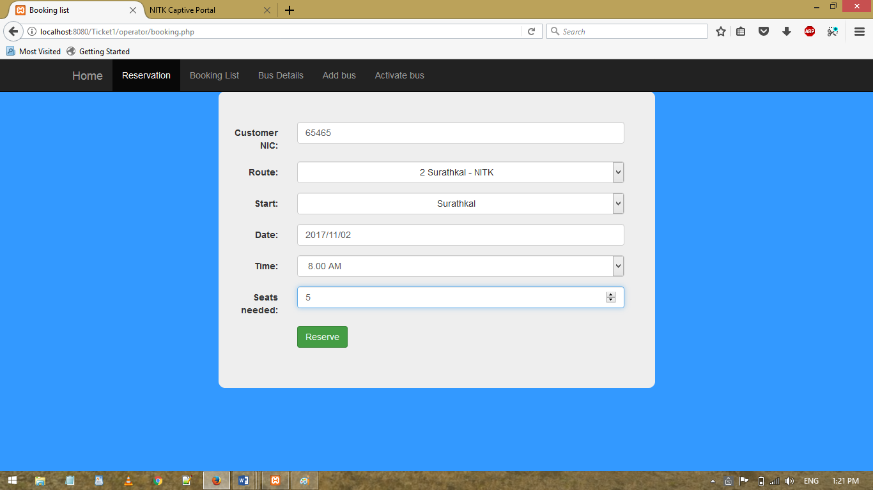

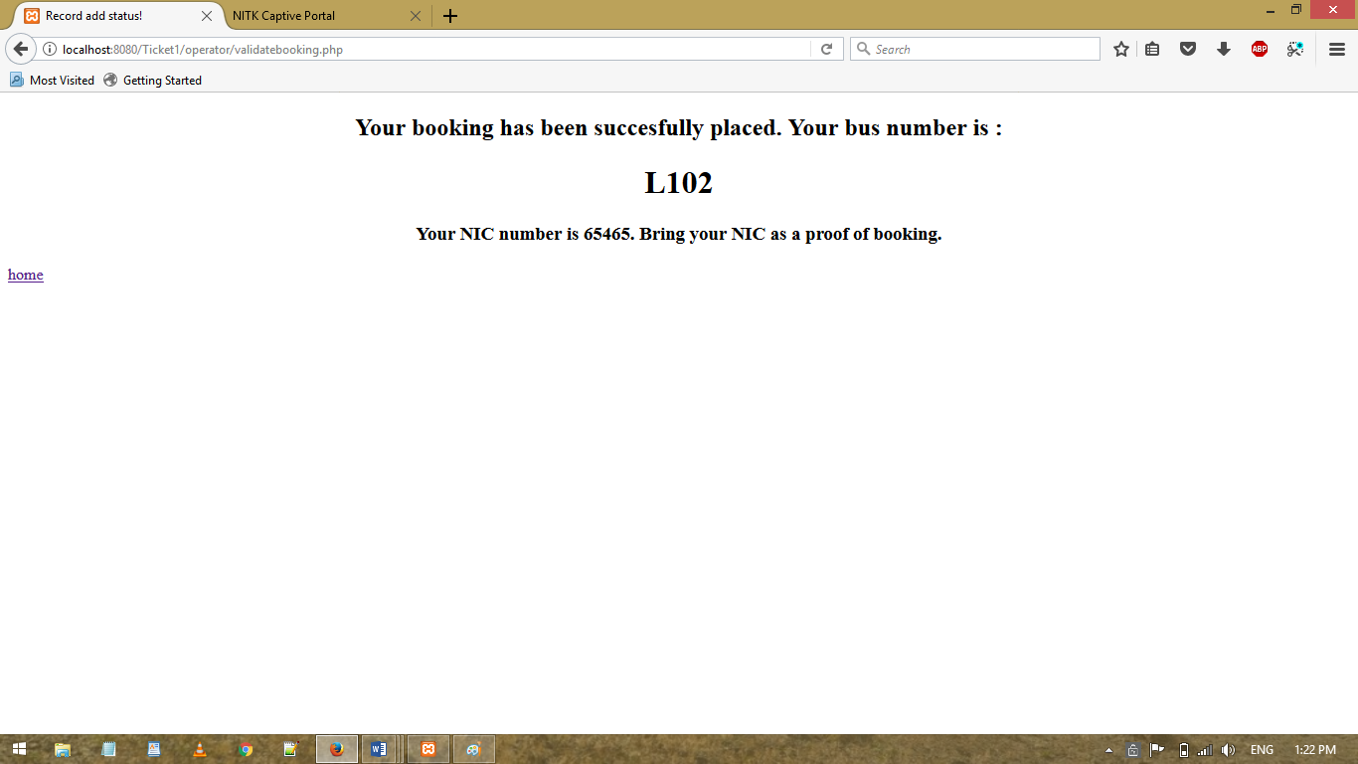

### View all Bookings

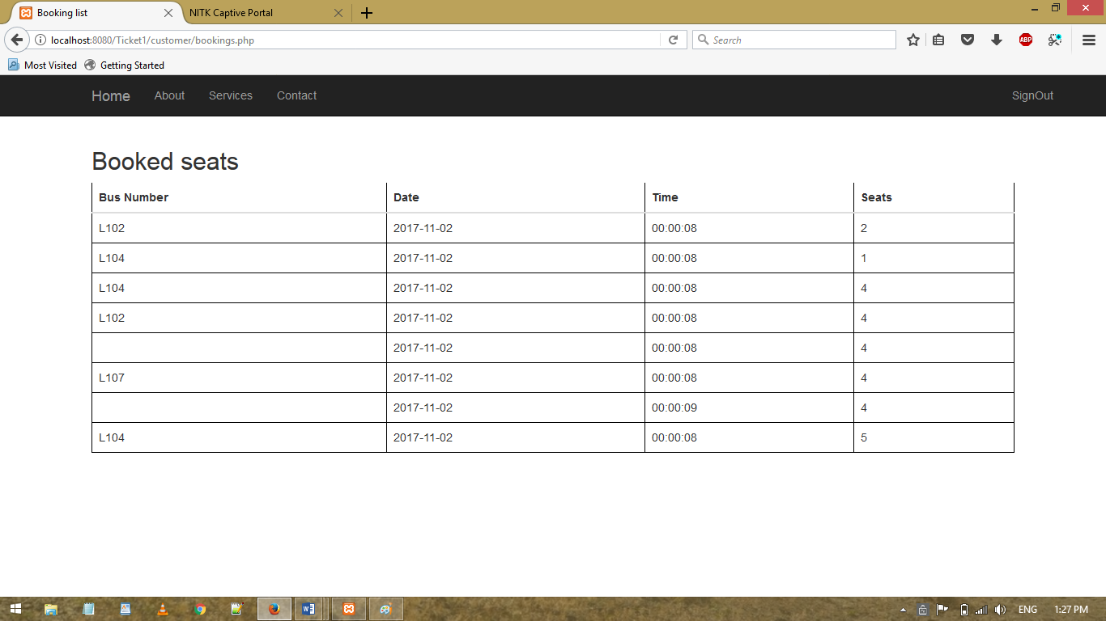

### Register new Customer

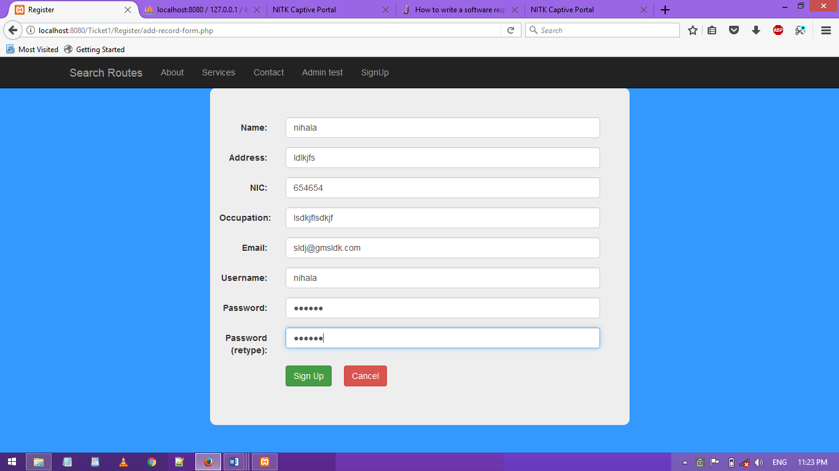

### Login as Customer

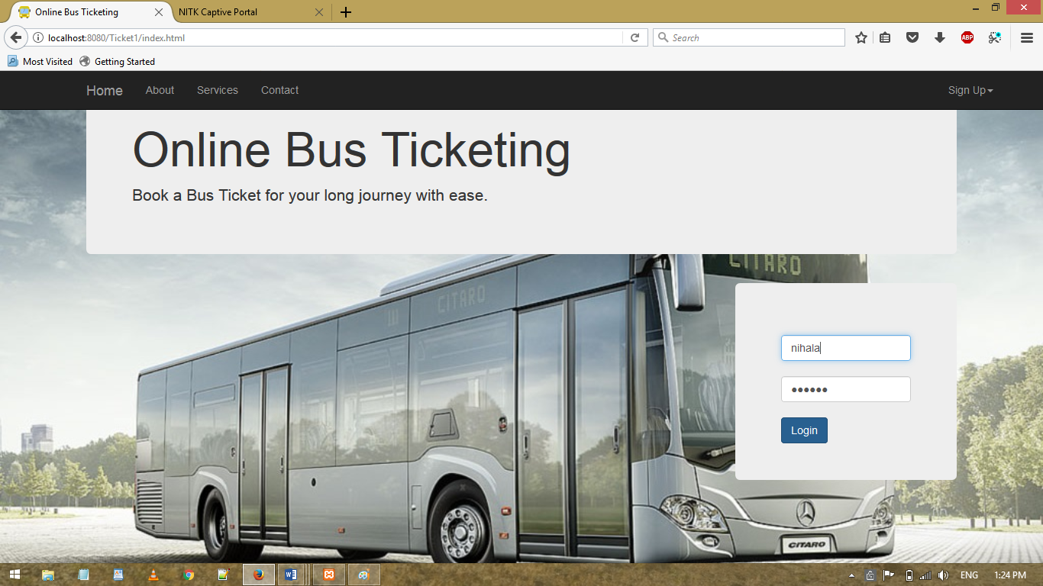

### Reserve a Bus seat as a Customer

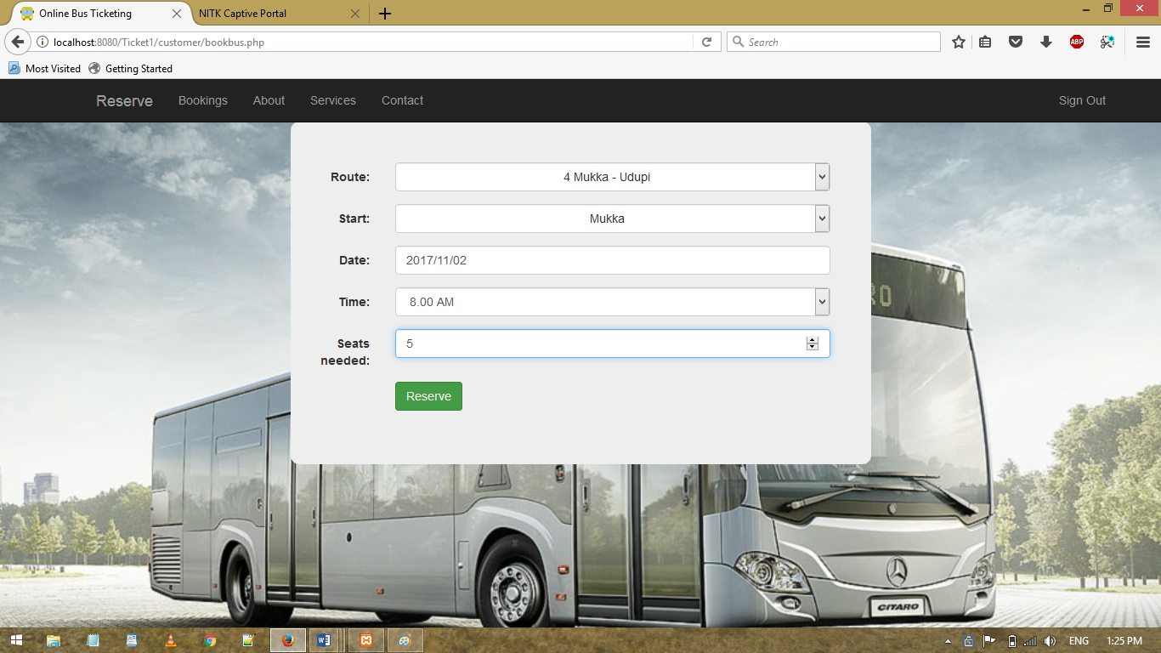

Here the customer can mention that he's booking for multiple seats. In the backend, there is an attribute that will take care of updating this value.

### Handle Failed Booking

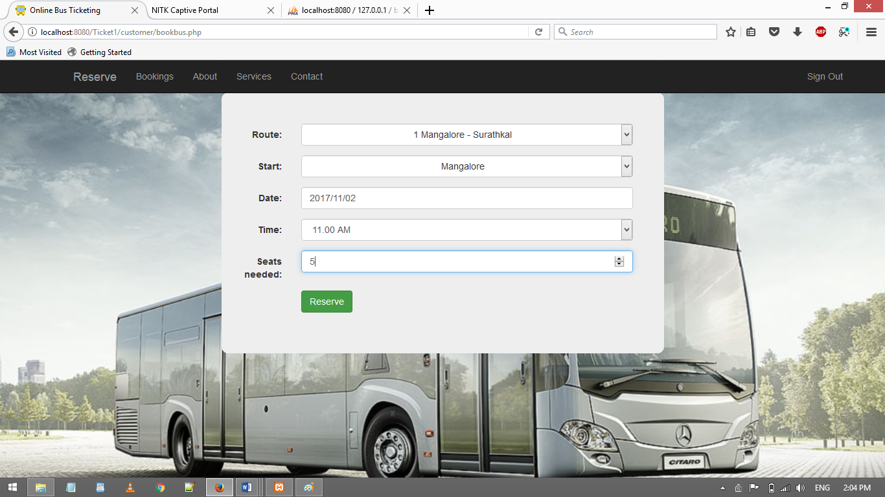

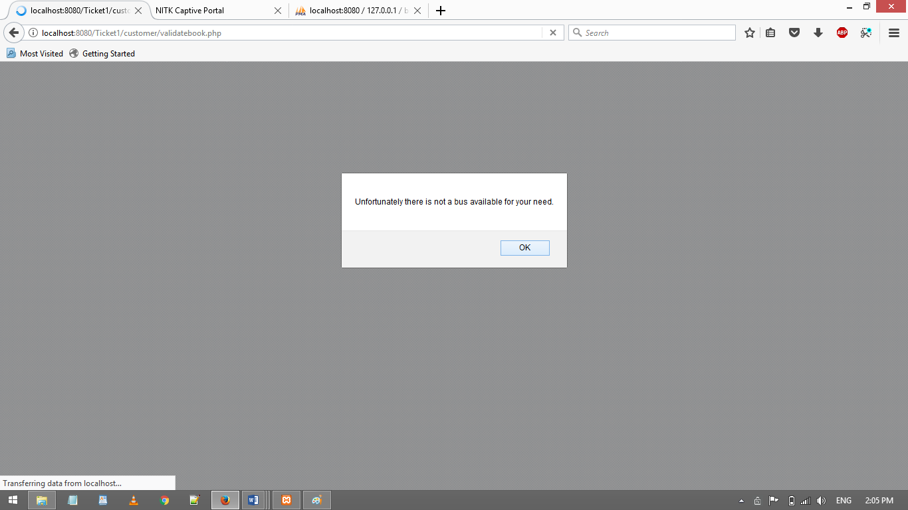

The booking failed as there is not a us that follows the route required.

### Sign Out

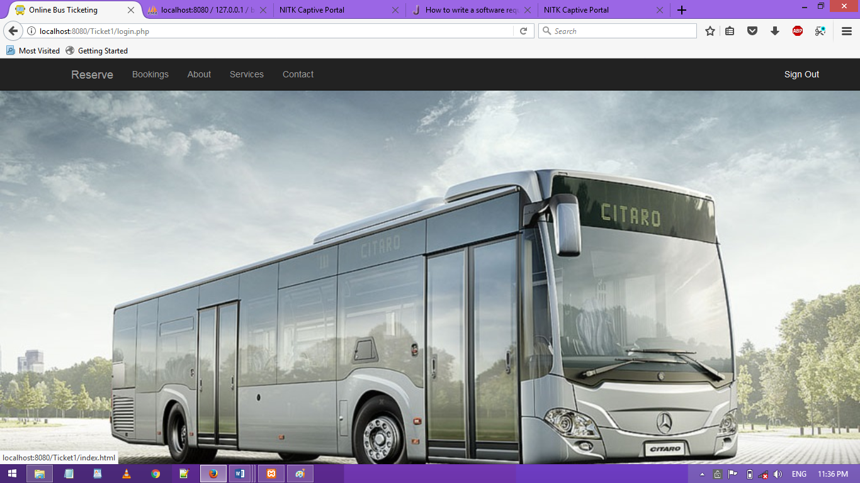

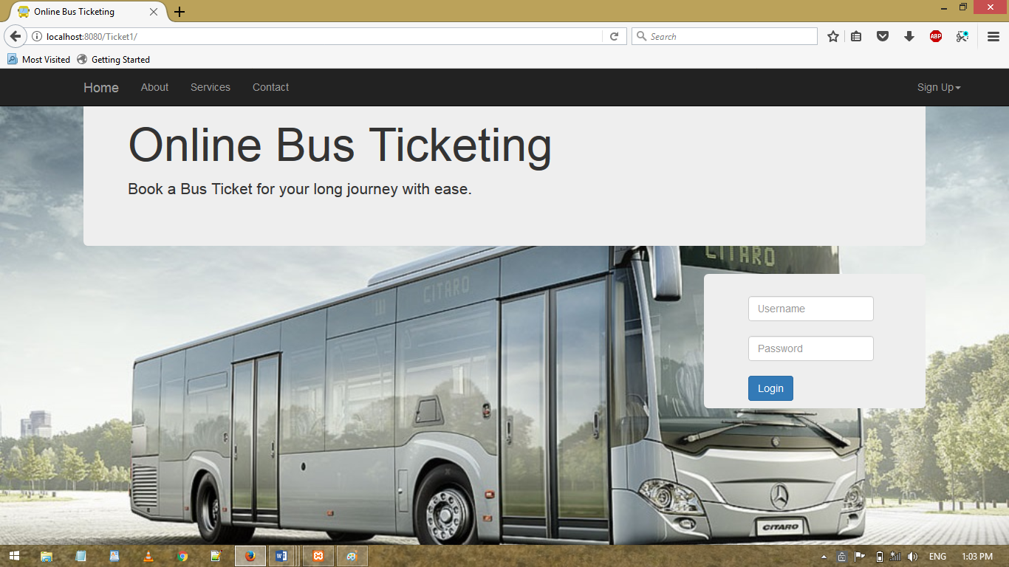

# NON FUNCTIONAL REQUIREMENTS

## Performance

### Capacity

Supports one logged in user at a time in the database.

### User interface screen

Responds within 5 sec

### Response time

Within 2 seconds after entering the required details.

## Reliability

Reliable through the Backend MySQL setup

## Security

The Customer password is needed so that other people cannot book a false seat(s) under the customer's name, and this ensures credibility and payment safety.

Bus Owner password is needed to access buses tables. So apart from the bus owners no one would be able to access the tables, and corrupt the bookings of the customers.

For the backend Admin, password is needed to update city map details, and this person has access to the whole setup of the ticketing. Besides this person, no one should be able to change anything.

## Supportability

Failed booking details are maintained, and future updates to this system can request the customer if they would like to rebook their seats.

## Implementation

A web site has been designed so that multiple users can access this site.

## Interface

Clean web pages have been designed for easy readability and assisted navigation. The linking of these pages has been done.

# DESIGN

# 

The database is in 3rd Normal Form. The data redundancy has been reduced, and the transitive functional dependencies have been removed. Data integrity is at its best, and the database will not suffer update anomalies.

# 

# BACKEND SCREENSHOTS

# CONCLUSION

The main aim of the project has been successfully implemented, however there is a lot of scope for improvement.

Some of them would be

* Search results in buses could be better networked. For example, if a booking wants to go from Surathkal to Udupi, a result would not be shown, even though there is a bus from Mangalore to Manipal.
* Extending the City map to handle more complicated routes and cities such as Bangalore or Mumbai.
* Include a payment portal and provide offer codes and discounts to customers who are frequent travelers.
* Allowing users to update their details, and including more details for better transparency of the customers.

All in all, the basic system is functional and it will be easy to add more functionalities to it.

# Code Repository

https://github.com/nihalakp/City-Bus-Management-System--DBMS